Brittany Ferries’ Salamanca
Press Pack

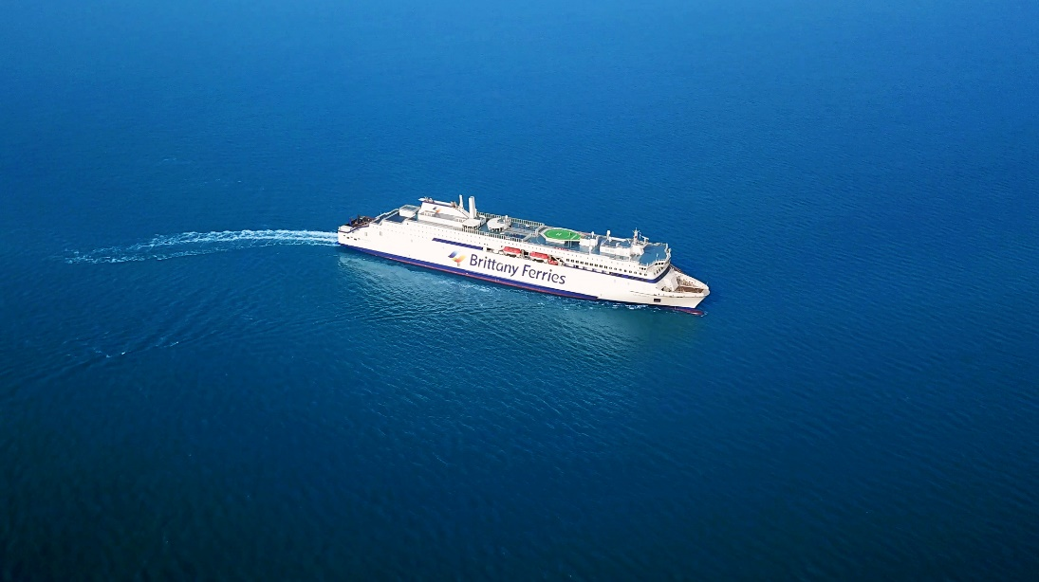
February 2022

Contents

Welcome Salamanca 2
Future-proofing the fleet: clean today, but cleaner tomorrow 3
Creating a new 'gas culture’ at Brittany Ferries 5
The benefits of sailing on LNG 7
Building the future – the E-Flexer story 8
Refuelling our ship, virtually and in Spain 10
Technical innovation comes as standard 11
The inside story – designing a ship to wow passengers 13
Where to go on board : shops, restaurants, lounges and beautifully appointed cabins 15
From Velázquez to virtual art, a collection to treasure 17
Build dates and technical data: 19

Welcome Salamanca

Brittany Ferries is proud to announce the arrival of the company’s first LNG (liquefied natural gas) vessel.
Salamanca is a sister-ship to Galicia (launched in December 2020) and represents a significant step in the company’s fleet renewal plan. She promises a smoother, quieter voyage for crew, passengers and freight drivers. And significantly lower emissions for port partners, maritime neighbours and wider society.
Salamanca embodies the sights, sounds and tastes of the region she will serve, giving passengers an experience of their destination from the moment they step on board. From delicious food and comfortable cabins, to fine art and an exclusive C-Club lounge, Salamanca will surprise and delight throughout a voyage.
Like Galicia, Salamanca is an E-Flexer type vessel, constructed by partner Stena Ro-Ro. The E stands for efficiency and Flexer for flexibility. These are two motifs that apply equally to three further vessels of this type set to join the Brittany Ferries fleet.
In 2023, a second LNG-powered ship Santoña will join her sisters, adding further capacity on UK Spain routes. She will be followed by two LNG-hybrid vessels which will replace two much-loved but older ships Bretagne (1989) and Normandie (1992), serving routes linking the UK with France.

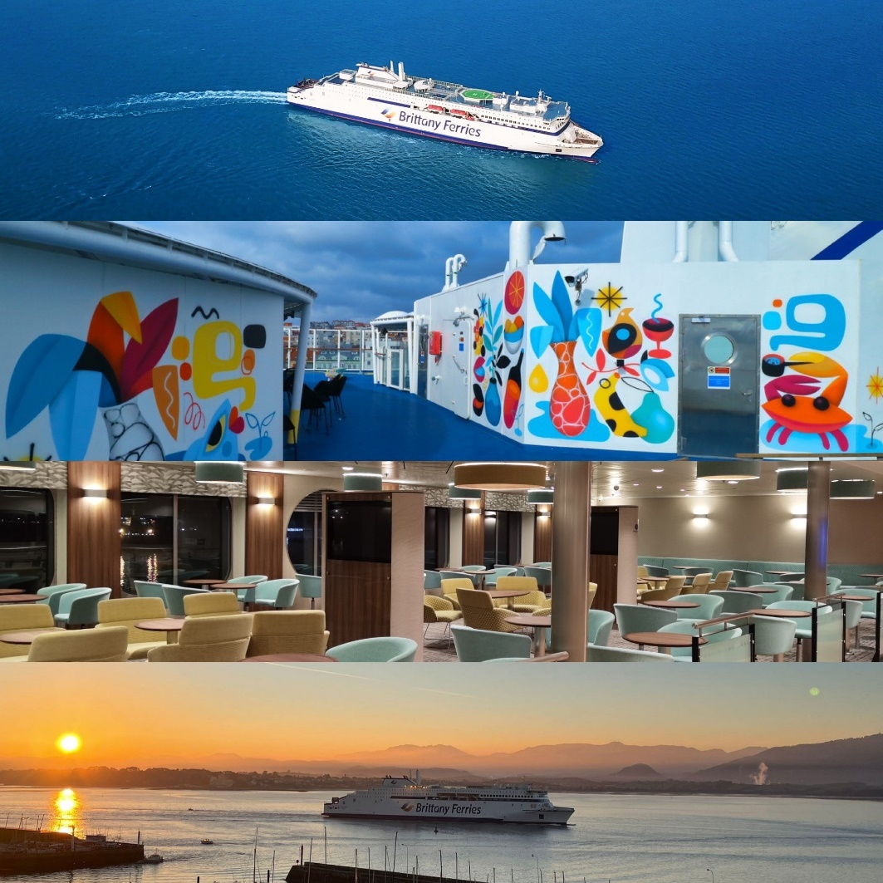

Future-proofing the fleet: clean today, but cleaner tomorrow

Brittany Ferries' new ship Salamanca is not only its first to be powered by liquefied natural gas (LNG), but also the first LNG-powered ferry to connect the UK with the rest of Europe.

Her maiden voyage is a milestone in the greening of the Brittany Ferries fleet, but far from the end point. Not only are ferries with even more advanced hybrid technology on their way, but Salamanca and the three LNG-powered sister ships which will follow her have been future-proofed.

They have designed from the outset to be fuel-agnostic, meaning they are capable of switching to even cleaner energy sources as they become available, such as bio-LNG and e-methane. So instead of becoming outdated, they should actually get cleaner over their long service life.

The benefits of LNG are clear. Local air quality pollutants such as particulate matter, sulphur dioxide and oxides of nitrogen are almost completely eliminated, dramatically reducing Salamanca's impact on those living and working around the ports she serves. Carbon dioxide emissions are cut too, by up to 20 percent, and combustion is more efficient.

Passengers will notice her smoother, quieter running and visibly cleaner funnel emissions. Working conditions for her crew will be more agreeable too, and the running of her twin Wartsilä engines can be more finely tuned to suit her cruising speed, resulting in even greater efficiency and refinement.

But just like the switch to hybrid and electric power in the car industry, the technologies and fuels available to responsible ship owners are evolving rapidly, and Brittany Ferries plans to stay ahead of this curve.

LNG is the best way to reduce the environmental impact of the ferry industry today, but it is likely to be superseded by better, lower carbon options in future. Fuels and technologies now in the early stages of their development such as e-methane have the potential to reduce CO₂ by up to 80%. When they can be commercialised and produced at scale, Salamanca and her sisters will be ready.

Brittany Ferries was only able to bring an LNG-powered ferry into service so early by spotting the potential of the fuel over decade ago - and acting on it. It remains firmly committed to bringing new technologies into service as soon as they become viable.

Salamanca and Santoña - Brittany Ferries' next E-Flexer vessel, due in service next year - are powered by LNG, but the two further E-Flexer vessels (destined for France-UK routes) will add radical new hybrid systems to their LNG engines as that technology matures, allowing them to run near-silently and entirely emissions-free while manoeuvring and whilst in port.

But Salamanca and Santoña won't be left behind. Given the long service life of a passenger ferry - typically twice that of a merchant vessel - Brittany Ferries has designed all four of its new LNG-powered ships to be 'fuel-agnostic'.

Around the world, start-ups and the major fuel companies alike are working hard and fast to develop even better, cleaner fuels for shipping, and Brittany Ferries is tracking their progress closely. Biomethane, synthetic methane, ammonia and hydrogen all have the potential to reduce not only a ship's local pollutants, but also dramatically cut its carbon emissions: in some cases to almost zero.

The LNG-powered e-Flexers are capable of switching to these new fuels as they become available at scale. And crucially, ferries like these create the demand for such fuels, providing an added incentive for producers to get them to market.

Such vision requires investment. The on-shore infrastructure required to refuel LNG ships simply didn't exist, so Brittany Ferries has had to create it, in partnership with the Spanish energy giant Repsol. LNG terminals are now under construction in Bilbao and Santander.

It is also investing now in the on-board technology required to use those future fuels, and it remains committed to these investments despite the significant twin headwinds of Brexit and COVID.

"It's actually our history that allows us to look to the future in this way," says Frederic Pouget, Brittany Ferries' Ports and Operations Director. "Our shareholders are still the farmers who first founded Brittany Ferries. We are incredibly lucky to have such patient, far-sighted and long-term owners. They're focussed on the bigger picture, rather than short-term returns. In a different company we might have had to wait until these technologies were more commonplace and their cost had declined.”

“But by then it would be too late. This generation of ferries would have been built, and in service for years with more polluting technology. We're lucky to work in a company and a culture where this kind of vision gets the investment it needs."

Creating a 'gas culture’ at Brittany Ferries

And why the shift to LNG is far more profound than just choosing the green pump over the black

The adoption of liquefied natural gas as the fuel for Brittany Ferries' future fleet requires profound change across every aspect of the business. It's a far more significant shift than switching between petrol and diesel in road transport, and is better compared to the switch to electric power in cars. In both cases, the infrastructure to deliver the energy often has to be constructed from scratch. And although both electric vehicles and LNG vessels look like their conventionally powered counterparts, the engineering beneath is entirely different, as is the way they are operated.

So Brittany Ferries is on a mission to create a new 'gas culture' across the business, and it's a shift being enthusiastically embraced throughout the business. But the first step was simply to get the gas to the new ships. Because Brittany Ferries is the first to operate clean-burning LNG vessels from the ports it serves, new infrastructure required to refuel them was needed.

A partnership with Spanish energy giant Repsol includes the construction of two new LNG refuelling facilities in Bilbao and Santander. Each is capable of storing up to a thousand cubic metres of LNG. The first, in Bilbao, comes on-stream in time for Salamanca's maiden voyage, with Santander following in time for Santoña's arrival in 2023.

Bertrand Crispils is Brittany Ferries' LNG expert, having spent much of his career at sea on liquified gas carriers and working in LNG production before joining the company a decade ago as its project to transition to LNG began. Now he plays a central role as guardian of the company's new gas culture.

"We've made a huge investment in training," says Bertrand. "You don't operate an LNG ship in the same way as one that runs on conventional fuels. There's a different culture on LNG ships and incredibly tight safety procedures. That's why they're safe."

"LNG is a complex product, and to manage it you need to expand your expertise into areas such as thermodynamics. But our staff have responded amazingly to these new challenges, and have really welcomed the chance to expand their experience and their competence."

That experience started to build even before Salamanca was delivered, with Brittany Ferries investing in an advanced virtual refuelling simulator, allowing staff to familiarise themselves with Salamanca's operations a year in advance of her arrival. And that expertise will grow even more quickly once she's in service.

"When I was working on big gas carriers, we might perform a bunkering operation - filling the ship with gas - once every three weeks," he says. "But Salamanca will be refuelled twice a week, as will each of her sister ships when they come into service. So our expertise with LNG will deepen very rapidly as soon as Salamanca is fully operational."

"We're already getting team members who will be working on Salamanca volunteering to come ashore to work in our training centres to pass on the experience they'll be building. They're excited by this switch to gas and feel like they have a responsibility to pass on their knowledge. That's great to see."

Bertrand lectures on the transition to LNG at marine academies and believes that the best young mariners beginning their careers will look at the environmental credentials of their future employers, giving Brittany Ferries a significant recruitment advantage. He also believes that over the course of their careers, new and even cleaner propulsion technologies will become viable, and he and the rest of the leadership team are committed to ensuring that Brittany Ferries is among the first to implement those too.

"It's a really exciting time to be working in shipping as these new technologies reach maturity. We need to keep cool heads, follow all the research closely, and be ready to move decisively when the time is right, as we did with LNG. It's exciting to be working at a company which does that, and which is motivated by more than just profit."

Illustration - by Bertrand Crispils

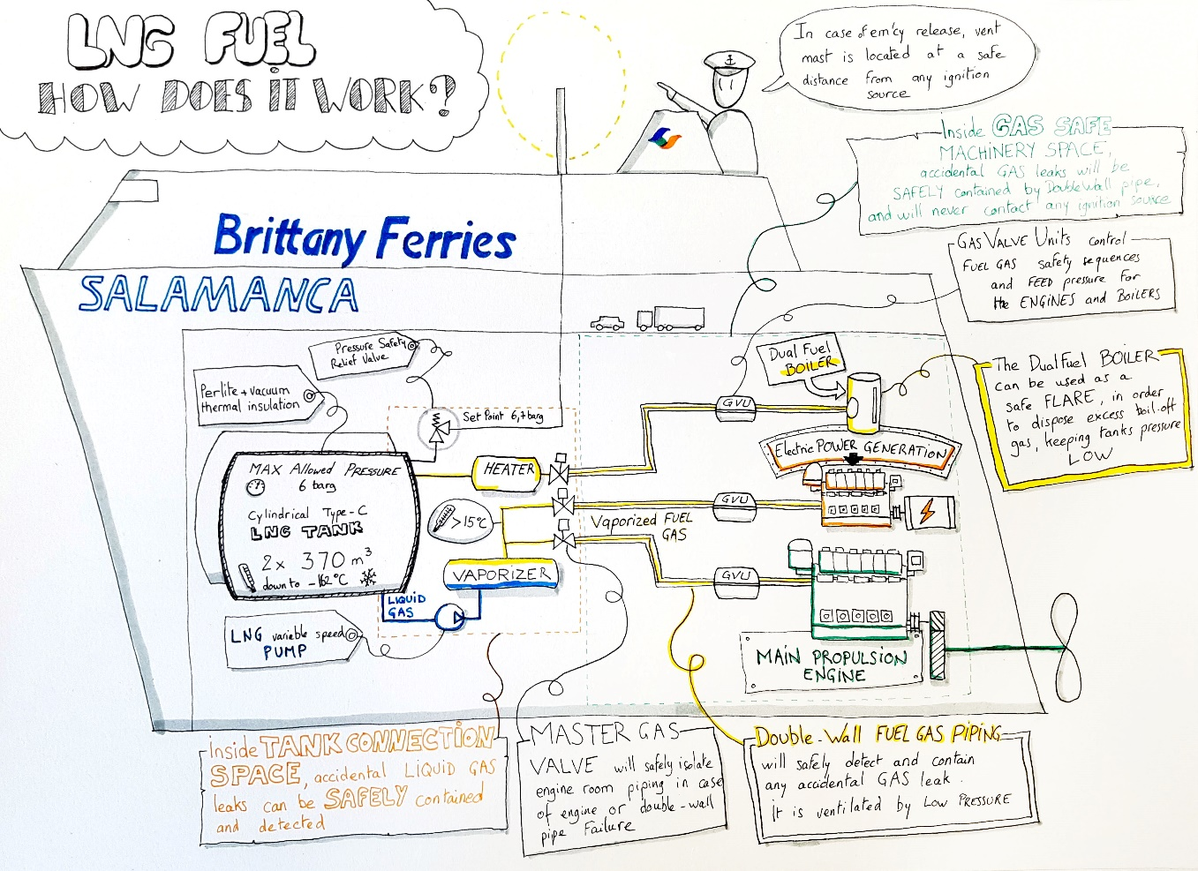

The benefits of sailing on LNG

Although Salamanca is not the first ship to be powered by LNG, she will be the first regularly operating on the Channel. Ferry services powered by LNG already operate in the Baltic Sea and the technology is tried, tested and safe.

As the name implies Liquefied Natural Gas, relies on a process by which a liquid is created from a naturally occurring gas. Gas is cooled to temperatures of -162 degrees Celsius, which shrinks it by a factor of 600 in volume, creating a liquid.

LNG is colourless and odourless, and many thousands of cars and commercial vehicles are currently fuelled by LNG. It’s a more efficient combustion process than burning traditional fossil fuels, with around 20% fewer carbon dioxide emissions. More significant benefits come from the fact that emissions are sulphur-free and there is a significant reduction in nitrogen dioxide and PM (particulate matter). These are air quality emissions that can be linked to respiratory problems.

LNG is now becoming increasingly common as a fuel for passenger ships. Ferry lines such as Viking Line and Tallink, as well as cruise lines like Carnival, Aida and MSC, have turned to LNG.

Ships operating on LNG have an excellent safety record and are required to comply with a set of regulations known as the IGF code. This has been specifically developed for the use of gas as a propellant, with safety elements drawn directly taken from ocean-going LNG carriers. This sector has operated without major incident for the last forty years, with many LNG carriers able to handle up to 120 000 m³ of LNG.

LNG is not perfect, but it is a significant step in the right direction. It is favoured by regulators and everyone who is concerned about protecting our planet. The European Commission’s Energy Roadmap 2050 for example, points to natural gas as key to aspirations for clean energy targets in 2050.

Salamanca’s funnels at sea – note near absence of visible emissions:
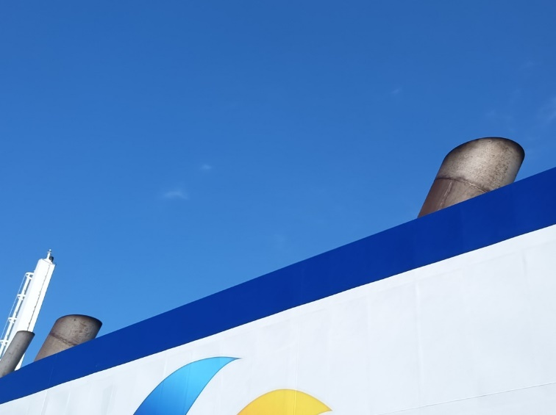

Building the future – the E-Flexer story

How Salamanca and her sister ships unite the benefits of mass production and bespoke

Salamanca is the second of five advanced E-Flexer vessels to have been ordered by Brittany Ferries. She follows her sister ship Galicia into service, with Santoña arriving in 2023 and two further ships in subsequent years. Together, these five ferries will transform the company's fleet. Four will be powered by clean-burning LNG, and the final two will add advanced hybrid propulsion systems. But the way they have been commissioned and constructed is just as innovative as the way they are propelled.

The five ferries are part of a fleet of twelve E-flexers being built by Stena RoRo at the China Merchants Jinling shipyard in Weihai, on China's eastern seaboard between Beijing and Shanghai. Starting with a standard design and building in large numbers - by marine standards - brings all the advantages of mass production: higher quality, lower cost, and rapid delivery.

But it also allows each ferry to be customised to its operator's needs. The five Brittany Ferries E-flexers will feature not only innovative new propulsion systems but also bespoke passenger areas delivering the unique touches the company's passengers have come to expect: fine food, fine art, and a taste of your destination to inspire you before you arrive on holiday.

Brittany Ferries participates in the construction of each of its new E-Flexers from the moment the first steel is cut. These are Brittany's biggest vessels to date, with a length of 215 metres, 2.7km of lane space and room aboard for over 1,000 passengers. As with other E-flexers, the company has made significant alterations to the design and engineering of Salamanca, including specifying its preferred Wartsila engines running on LNG, and reconfiguring the interior spaces to include more private passenger cabins.

And of course, the customer areas will be unique to Brittany Ferries, with the interior fit-out completed in Santander. Her IT systems, Wi-Fi network, furniture and artwork were also installed in Spain. In dry dock her advanced low-friction silicon paint was applied to her hull.

"The construction yard is very professional, highly organised, and sticks to its schedules," says Bertrand Cholley, who has been given the complex task of supervising the introduction of all five E-Flexers.

"Crucially it also had experience with LNG in constructing other kinds of marine vessel. But what we've been most impressed by is the standard of the accommodation. A technical issue with a vessel when it's in service often goes unnoticed by passengers. But if there’s an issue in your cabin or in the restaurant then you notice straightaway. Building cabins and passenger lounges to our standards is a demanding and complex business, but the quality is even better than we'd anticipated, and of course we then refine it further with our bespoke furnishings and artwork."

The mammoth 10,322 nautical mile journey from the shipyard to Santander via the Suez Canal was an opportunity for the crew to familiarise themselves with Salamanca. Her first-ever refuelling stop on LNG came at Singapore, with further stops in Sri Lanka, Malta and Cartagena in Spain. By the time she arrived in Santander she had 26 crew aboard with the benefit of nearly a month's experience at sea.

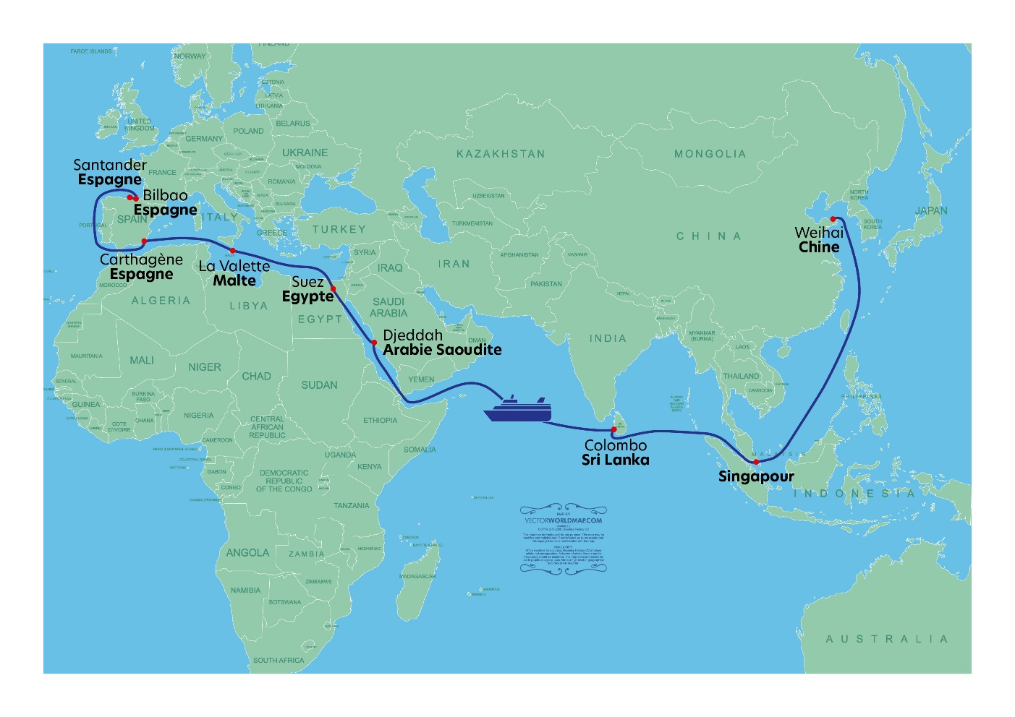
"The challenges with our future hybrid vessels will be more technical," says Cholley. "The challenge with Salamanca and Santoña is more human. LNG is already widely used in other industries and in other sectors of maritime transport. The demands of using it at sea are well understood. But it is still relatively new in passenger ferries, and new to Brittany Ferries, so as well as designing these ships to our needs, we have to design-in new safety procedures, build our experience with LNG. In short we have to create a new 'gas culture' throughout Brittany Ferries."

"As mariners we are obsessed by safety. We will push hard and fast to find new and better and cleaner ways to power our ships, but never at the expense of safety."

Cholley's attention now turns to Santoña, whose hull and superstructure are already complete, and to the first steel cut on the first of Brittany Ferries' two hybrid vessels, due in service in 2024 and 2025. It's a huge task, but this lifelong ship’s superintendent is relishing it.

"I love the fact that at Brittany Ferries, there is something new to work on every year: new technologies, new and cleaner types of energy, new challenges for us and our crews. It's a fascinating time to be working here, and I am proud to be a part of it.”

Refuelling our ship, virtually and in Spain

With four LNG vessels on the horizon, Brittany Ferries is working hard to instil a culture of gas-readiness among all staff. Training is of course key.
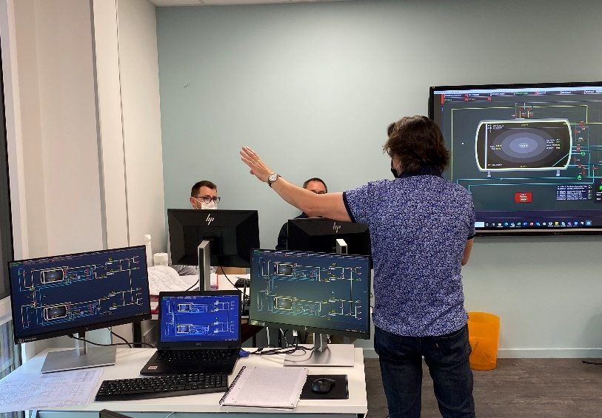
The LNG simulator in St Malo (image right) is a digital mock-up of the Salamanca's LNG fuel-loading, storage and preparation systems. It enables teams to be trained in their operation, reproducing any situation with which they may be faced.
Virtual bunkering (re-fuelling) can be undertaken in a wide variety of simulated situations. The simulator also allows staff to train in maintenance, and to practise specific procedures such as the complete shut-down of the LNG system.
This simulator is compact and mobile. It can be used for training onboard the ship when in service. Training modules were finalised in September 2021 and the first to undertake the programme have been Salamanca's crew who will be involved in LNG fuel operations.
Bunker terminals in Spain
In September 2021, Brittany Ferries welcomed the start of construction of LNG bunker facilities in Bilbao. The development undertaken by long-term fuel partner Repsol paves the way for Salamanca’s arrival in the port. A separate LNG bunker facility is also under construction in Santander in preparation for LNG-powered Santoña’s arrival in 2023.
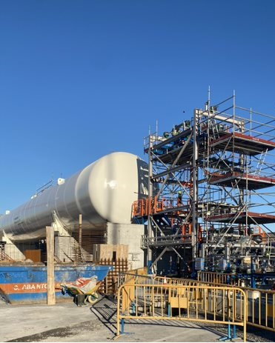
“I applaud Repsol and our port partners in Bilbao and Santander for driving this forward,” said Christophe Mathieu Brittany Ferries CEO. “The move to cleaner, green fuels relies on an integrated approach that connects vehicles with fuel suppliers and other important partners like ports. We look forward to the completion of works as we welcome our first LNG-powered ship to the fleet.”
The Bilbao facility hosts a cryogenic tank (see image right) with a storage capacity of 1,000m³. This permits natural gas to be kept in a liquid state at -160°C. The terminal’s flexible design allows it to service different vessels in the future, representing an important decarbonisation opportunity for port operations. This project benefits from an investment of more than €10 million by Repsol.
Both Spanish terminals are to be co-financed by the European Commission through the CEF- Connecting Europe Facilities Programme.

Construction – Bilbao

Technical innovation comes as standard

For years there has a been a great sense of anticipation about the arrival of Brittany Ferries’ first LNG vessel. But it’s not just those who will be travelling on board who have been looking forward to the first voyage.
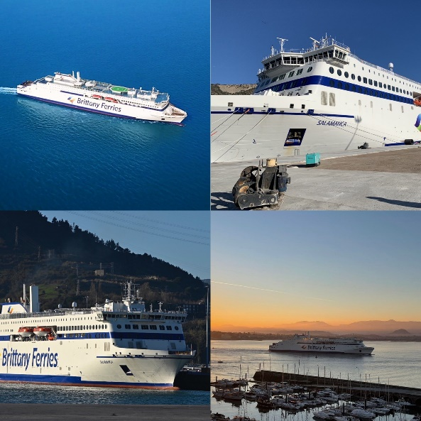
Thanks to a host of technical innovations, design optimisation and of course her cleaner fuel, Salamanca will be welcomed by those living and working around the ports in which she operates.
Her modern fuel-injection engines help smooth the ride at sea. But in ports, LNG fuel ensures that funnel emissions are kept to a minimum. Air quality pollutants, like soot and NOx, are almost entirely eliminated from the combustion process which is positive news for residents in ports like Portsmouth, Brittany Ferries’ UK hub, which will serve as the UK base for the ship.
“When it comes to ship design, there are never any concessions in terms of safety: we always apply the highest standards,” explains technical director Arnaud le Poulichet who has followed the development of this second E-Flexer class vessel throughout her build. “But sustainability is also absolutely integral to our fleet renewal strategy too.
“Passengers, crew and port partners expect companies like Brittany Ferries to invest in cleaner, less polluting vessels. Today we meet this challenge with Salamanca. But next year she will be joined by our second LNG vessel Santoña, connecting the UK, France and Spain. Then, a little further on the horizon, we will welcome two LNG-hybrid vessels to serve UK to France routes. These hybrids will serve as replacements for two of our oldest ships in the fleet, Bretagne and Normandie.”
The ‘E’ in E-Flexer stands for efficient
Like Galicia (the first E-Flexer class vessel now in operation with the fleet) Salamanca benefits from a long, slender hull and bow, helping deliver a high level of hydrodynamic performance.
Finned, anti-roll stabilisers have already demonstrated their benefit to passengers travelling on Galicia through stormy seas in the Bay of Biscay. The same system will assure similar levels of comfort for those travelling on board Salamanca. Friction-reducing silicon paint applied to her hull, helps smooth her passage through the water, reducing fuel consumption too.
Hydrodynamic efficiency and excellent seakeeping have allowed the installation of just two engines instead of four on equivalent vessels, which represents a considerable energy saving. In this way ships like Galicia and Salamanca are analogous to modern, twin-engine aircraft.
Each Wärtsilä 12V46DF engine has a power output of 13,740 kW, while variable speed alternators provide the means to recover energy even at low speeds, saving fuel and reducing CO₂.
As LNG-powered engines produce almost zero sulphur oxide emissions, Salamanca has no need for an integrated scrubber. Operating without one means lower electrical consumption.
There’s no need for stern thrusters either. Bow thrusters operate with flap rudders, of high lift type with twisted leading edges, smoothing turns in port.
Thanks to the use of powerful real-time data analysis on board the ship and the development of machine learning, energy efficiency can be optimised at all times. Supporting port manoeuvres, the ship comes with a new navigation tool named ‘smart quay system’. This is designed to help captains with the approach to a berth, and also helps reduce manoeuvring time.
Emission improvements
LNG propulsion promises a step change in air quality improvement, with the near absence of soot, NOx and SOx emissions. But CO₂ output per passenger is down too.
Aside from her suite of technical innovations, and the inherently greater efficiency of LNG combustion compared with other marine fuels, Galicia and sister-ship Salamanca will replace Baie de Seine and Cap Finistère (sold in February 2022). These are less efficient vessels with much smaller passenger and freight capacities. That means a significant reduction in carbon footprint on Brittany Ferries’ long-haul services operating routes between the UK and Spain, thanks in part to a large increase in carrying capacity.
Sound and light
Noise pollution can be a nuisance for port neighbours, but Brittany Ferries’ experience of E-Flexer ships continues to be positive. Insulation and silencing on Salamanca are excellent, meaning noise is kept to a minimum. On shore Salamanca’s generators are far less noticeable than for other ships, and are – of course - well within the specifications of regulation.
The company is also working to enable electric vehicle charging on board. It should be possible, for example, for an electric vehicle driver leaving Portsmouth to charge their car on board and arrive in Spain with a fully charged battery.
In the meantime, garage decks will be illuminated by LEDs – alongside every light on board the ship – revealing another electrical innovation: Salamanca will operate an integrated electric forklift to manage the transfer of mechanical parts instead of a diesel one.

The inside story – designing a ship to wow passengers

How Salamanca’s bespoke interior reflects the ancient Spanish city whose name she bears
It all starts with the name: Salamanca. It’s a moniker that evokes centuries of history, art and knowledge. An historic centre that bears the title Unesco World Heritage Site and one of the oldest universities in Europe.
Step on board and passengers will find an interior experience inspired by the charms of this Spanish city. From artworks to catering, there are echoes of Salamanca throughout, as well as of the Castilla y León region, and Spain itself.
Sister-ships Salamanca, Galicia and Santoña share the same layout, meaning passengers will easily find their bearings when they move from one ship to another. But each ship has a very distinct character that reveals the destination it serves, and commercial concepts that are adapted to passenger requirements and expectations on a particular route.
Every detail is carefully thought through, from the bespoke carpet design to the choice of upholstery, fabric colours and artworks. And Salamanca’s finish is of the highest standard, partly because E-Flexer vessels are built in series, assuring high standards thanks to repetition and rigorous quality control.
Brittany Ferries entrusted the ships’ interior design to Richard Nilsson, a Swedish architect who created the original E-Flexer layout and design. Nilsson is a man who understands the constraints of operating at sea without compromising on the harmony of on-board spaces.
He worked closely with German marine interior specialist Rheinhold & Mahla, a company that also fits out high-end cruise ships. R&M constructed workshops at the shipyard in China to build cabins for Brittany Ferries’ ships, using only the finest materials and most exacting quality control processes.
Greek company Aluminox Marine were entrusted with the fitting out of the kitchens and bar, and the installation of artworks and specific fittings and finishings was carried out in Spain by Oliver Design.
But it was Brittany Ferries' strategy director Catherine Querné who was responsible for bringing the customer experience to life, overseeing the entire project as she does for the interior design of every new Brittany Ferries vessel.
“Our ultimate goal is to provide the very best experience on board,” she said. “The beauty of travel by sea is that your holiday starts as soon as you step on board. Our priority is to surround the passenger with authenticity, relaxation and wellbeing. The journey aboard Salamanca will inspire them ahead of their visit to this wonderful destination.”
Catherine, Richard Nilsson and artistic advisor Kimberly Poppe immersed themselves in the city and region before embarking on the project, allowing each to bring their own interpretation to life.
For Catherine it was love at first sight. "Salamanca is so rooted in history that you sometimes feel in another world. But because of its famous university, it also has an incredibly youthful and vibrant air. The artwork on deck 10 for example is inspired by the modern street art that enlivens the city’s old working-class districts. As for the food – well this is just wow.”

“We try to awaken all the senses on board, to bring a taste of Salamanca to passengers: the soft colours of the sandy beaches, the seaside restaurants, a taberna de tapas that makes you want to taste the Spanish flavours, photography of the city, comfortable cabins, cultural information and, of course, the warm welcome of our onboard colleagues.”
Catherine is already busy designing the customer experience aboard Santoña and two as-yet unnamed LNG-hybrid vessels to follow.
“The hybrids destined to serve St Malo and Ouistreham from 2025 are very much in our forward thinking. These ships are a new challenge, with their 20-metres shorter length to fit in our French ports. But, like Salamanca and Santoña in Spain, we will use them to promote the wonderful tourist regions of Brittany and Normandy.”

Rubén Sánchez – deck 10 exterior art
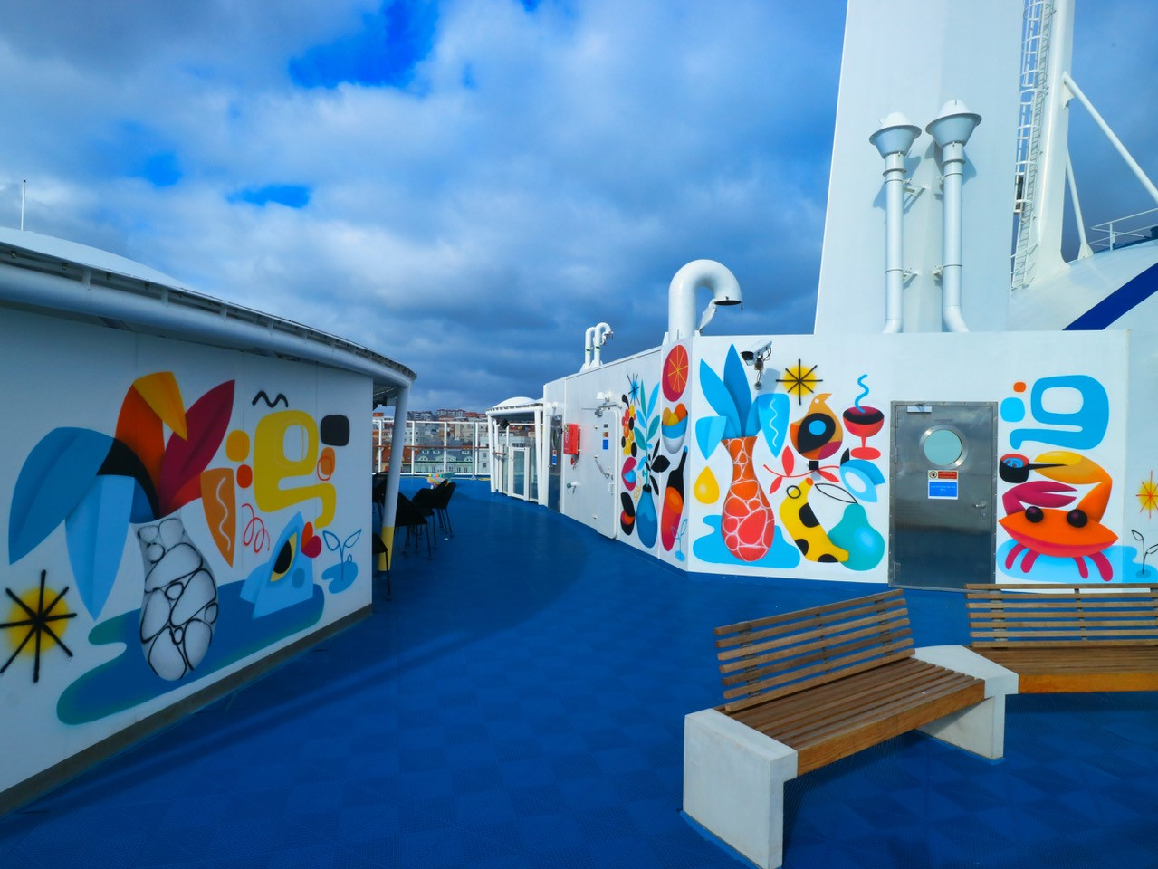

Where to go on board : shops, restaurants, lounges and beautifully appointed cabins

Style, comfort and attention to detail are to be seen and experienced everywhere aboard Salamanca. A tour around her decks takes passengers on a journey of discovery inspired by the town. Bright and spacious passenger areas await, hosting shops, lounges and cabins to support every need.
There’s a huge outside terrace on deck ten replete with dramatic artworks, three playrooms for children, numerous lounges, restaurants and bars and two large shops located in the heart of the ship. These cater for everything from perfume and souvenirs to wine and newspapers.
Salamanca also hosts a private C-Club lounge. This is an exclusive and peaceful space, offering an assortment of snacks and drinks. Open during the day, the lounge is free of charge for those with a cabin in Commodore class. However a limited number of additional tickets are available when booked at the information desk - or in advance online.
Of course, many passengers choose to spend the majority of their time in their own cabin. The good news is that Salamanca boasts some of the widest berths in the fleet. Furthermore, each cabin is equipped with a TV, as well as free video on demand (VOD), and the most comfortable of mattresses.
In total there are 343 cabins, all with en-suite bathrooms - and 37 cabins for lorry drivers. Some cabins have been adapted for passengers with reduced mobility and 22 are pet-friendly cabins reserved for passengers travelling with their dog or cat. Brittany Ferries carries around 100,000 four-legged friends per year. Galicia also hosts 21 Commodore Club cabins and three Commodores Suite cabins.
The following is a summary of each cabin type:
Commodore luxury suite: double beds (160 cm), free access to the C-Club lounge, direct access to the outside deck, TV + VOD and mini-bar (free soft drinks), breakfast option served in the cabin, sea view, large flat screen TV, free VOD on TV and personal devices (valid for everyone), tea and coffee maker, superior mattress, high quality bed linen and towels provided, free toiletries, hairdryer, UK/European and USB sockets.
2-berth Commodore Club: twin beds (two lower berths), free access to the Commodore C-Club lounge, water, tea/coffee making facilities, kettle/tea tray and sea view, large flat screen TV + VOD (for personal devices too), complimentary toiletries, hairdryer, UK/ European and USB sockets.
4-berth Club cabins with porthole: air-conditioned, equipped with twin bunk beds, window and en-suite bathroom, sea view, bunk beds, flat screen TV, VOD on TV and personal devices (valid for all passengers), hairdryer, UK/ European and USB sockets.
2 to 4 berth interior cabins: twin and bunk beds, air conditioning, flat screen TV + VOD on TV and personal devices, UK/European and USB sockets.
Wheelchair accessible cabins: 2-bunk bed cabin with porthole reserved for wheelchair users. These Premium Plus outdoor cabins are specially adapted for wheelchair users and have an alarm and telephone. Their availability is limited and early booking is essential. Twin beds, flat-screen TV + VOD on TV and personal devices, wheelchair access to the bathroom, UK/European and USB sockets. Ambient floor lighting wishing occupants “Bon voyage ˮ.
Pet friendly 2 to 4 berth exterior cabins: 4-berth pet-friendly cabins are air-conditioned, have a porthole, laminate flooring with space for standard size pet bed. Sea view, bunk beds, flat-screen TV + free VOD on the TV and personal devices (valid for everyone). Hairdryer, UK/European and USB sockets.
Pet friendly 2 to 4 berth interior cabins: 4-berth Standard Plus cabins have laminate flooring with space for a standard-sized pet bed and private bathrooms. Bunk beds, flat-screen TV + free VOD on TV and personal devices, UK/ European and USB sockets.
Lounge seating: Enjoy the comfort of a premium reserved seat offering you a dedicated place to relax (43 seats).
Baby cots are available, suitable for infants under 24 months.
Shopping experience
Located in the heart of the ship, the boutique is modern, elegant and welcoming. It offers two zones, the first is a large airport duty-free style shop with major brands of alcohol, tobacco, wine, champagne, delicatessen, confectionery, perfumes, cosmetics and accessories. A second area stocks travel goods and cultural souvenirs, as well as Spanish gastronomy.
Salamanca’s luminous sky-bar – image © A. Pinnec
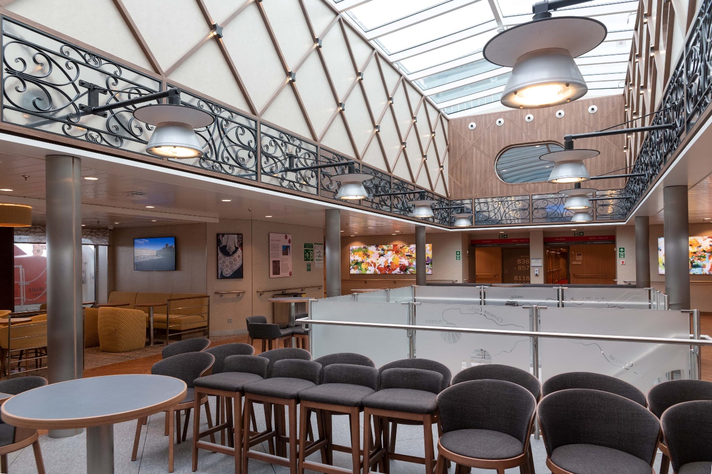

From Velázquez to virtual art, a collection to treasure

A varied and vibrant art collection reflects the nature of her namesake city
When Salamanca arrived in Santander for her final fit-out, one particularly important and valuable cargo was waiting for her on the quayside: her art collection. Perhaps even more than the name on the bow, the artwork aboard a Brittany Ferries vessel gives it an identity, reflecting the location and culture of the place which gives each ship takes its name.
It's a tradition which stretches back to 1989 and the works commissioned from Scottish painter Alexander Goudie for Bretagne, the company's first bespoke super-ferry, which were inspired by the region from which both the ship and the company took their names.
And it's a tradition which has only strengthened through the years. More than 200 individual artworks awaited Salamanca as she docked in Santander for the first time, and their installation over the three main passenger decks was the equivalent to the hanging of a major gallery exhibition.
But in a departure from tradition, one major element of her collection wasn't yet there. Instead, it was created aboard: a giant street-art mural painted directly onto Salamanca's steel on her sun deck by the graffiti-inspired Spanish artist Rubén Sanchéz, whose previous commercial commissions have come from Facebook, YouTube and Nike.
Brittany Ferries' first three E-Flexer vessels all serve Spanish destinations and bear Spanish names, and their art collections will reflect their specific namesakes and Spanish culture generally. All will be curated by American born, Amsterdam-based artist Kimberly Poppe, working in collaboration with Catherine Querné, Brittany Ferries’ Strategy Director. As with Salamanca's sister ship Galicia, Kimberly began her work with a journey with Catherine to the place the ship honours, to both draw inspiration for the art she'd commission, and to produce her own.
"Salamanca is a gorgeous city," she says. "It's built from this beautiful yellow-pink sandstone and at night, just as the sun's setting, the whole city is lit up in gold. It's an ancient pre-Roman city, and one of the first universities in Europe is based there, having been founded in 1218. Today, it's still a very lively student city so it has this combination of history and elegance, while also being vibrant and young. It also has a real sense of humour. One of the modern stone carvers who was finishing off some of the details on the cathedral carved astronauts and gargoyles licking ice cream."
"There's also a very characteristic Salamanca typeface which is used for the street names,” she continues. “And away from the centre of town there was a project to do street art on the garage doors so it's now full of these colourful murals. That was the inspiration for commissioning Rubén. He reflects this lively, younger, hipper aspect of Salamanca in particular with his bold graphic style. He’s Spanish, originally from Madrid, and much of his iconography is rooted in Spanish everyday life. He's inspired by Picasso and other Cubist painters, but he also has this skater and graffiti background, which makes him unique." Sanchéz also contributed the paintings for the Taberna de Tapas – Salamanca’s authentic Spanish restaurant.
Kimberly's own contemplative photography of Salamanca adorns the main public areas, with her imagery from the wider region of Castile and León, on the walls of the cabin deck corridors.

"The ship's bar is based on the Plaza Mayor in Salamanca, which is one of the most famous squares in Spain," she says. "I spent a lot of time there just hanging out and photographing the comings and goings at different times of day, which you’ll see in the images in the bar. The colours of the walls and the furnishings are inspired by the sandstone hues you can find there. And we've created some descriptive wall texts where you can discover more about Salamanca, using the Salamanca typography and the oxblood-red it's traditionally written in. Our hope is that when you sit down and have a drink in the bar, you’ll be transported to that feeling of relaxing in a Spanish square."
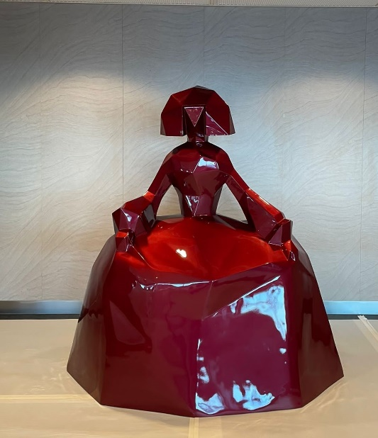
Drawing inspiration from Spanish culture more generally, the central female figure in Velázquez’s revered painting Las Meninas is again an inspiration throughout the ship, with a 'Casa de las Meninas' virtual interactive exhibition devoted to this endlessly reinterpreted theme in Spanish art. There are two large modern Meninas sculptures by highly regarded Spanish pop artist Felipao, and the Dutch artistic and photographic duo Nienke Klunder and Wiglius de Bie, who live in Spain and work together under the KlunderBie banner have provided their own interpretation of Las Meninas, alongside their photographic portraits of local salamantinos in traditional dress for the Azul restaurant.
Paintings by Karen Silve, based in America's Pacific North-West and Provence, France, and sand paintings by New York-based artist Mark Van Wagner round out the Salamanca's collection, and create a body of work so impressive you might struggle to explore it all, even on an overnight crossing.
"I think that's what's so cool about slow travel," says Kimberly, who is already curating collections for Salamanca's forthcoming sister ships. "You have the time to enter your destination even as you're travelling towards it. Hopefully passengers will be inspired by our art to explore more on their arrival, and enter into the spirit of Spain before they've even disembarked."

Build dates and technical data:

May 2018 | Salamanca ordered
10 September 2019 | Steel cutting
6 January 2021 | Floating out
30 November 2021 | Official « delivery » ceremony in Sweden
10 December 2021 | Departure from China on voyage to Europe
16 December 2021 | Brittany Ferries team take chage of ship in Singapore
12 January 2022 | Arrival in Bilbao
18 January 2022 | Raising of French flag (official classification)
27 March 2022 | First commercial sailing from Portsmouth to Bilbao

Technical data:
Length | 214.50m
Breadth | 27.8 m
Draught | 6.60 m
Gross tonnage | 41,716 UMS
Decks | 10
Passenger decks | 3
Speed | 23 knots
Passenger capacity | 1,015
Crew | 85
Cabins | 341
Pet cabins | 22
Vehicle capacity | 2,705 lane-metres
Engines | 2
LNG capacity | 783 m³

